**PROJECT TITLE:ENVIRONMENT MONITORING**

**Phase 1: Project Definition and Design Thinking**

**TEAM MEMBERS**

814821106020:MAHASRINATH M

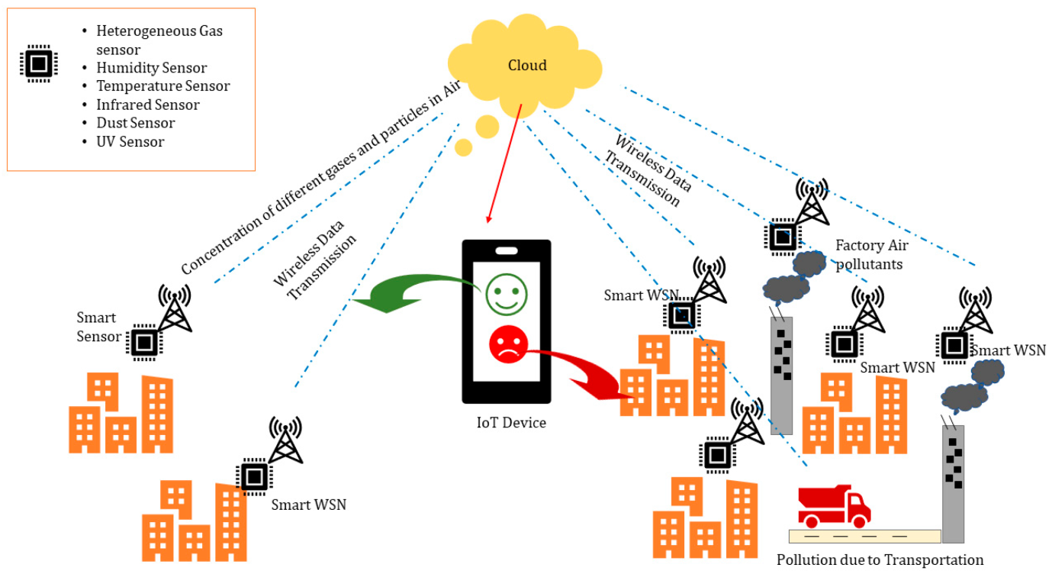

**INTRODUCTION**

*IoT[environmental monitoring](https://caburntelecom.com/industry-sectors/environmental-monitoring/) is a process that uses [Internet of Things (IoT)](https://caburntelecom.com/a-guide-to-iot-connectivity-and-iot-sim-cards/) technology to collect data about the environment, such as air quality, temperature, and humidity levels.

This data can then be analysed to better understand the indoor and outdoor environment and make informed decisions about how to reduce the impact of negative aspects of the local environment on the business. Alternatively, it can be used to change business activities to help protect the planet or the local community.

*These IoT-based systems can be used to detect issues in the environment that are largely invisible, normalised or taken for granted. Allowing businesses to take action by reducing their negative environmental footprint and protecting employees, visitors and the community at large.

**IOT DEVICES DESIGN**

By focusing on agriculture, as a relevant issue for the growth of any nation, it is easy to underline how SEM can play a significant role by providing a “smart or green agriculture” [[**14**](https://www.mdpi.com/1424-8220/20/11/3113#B14-sensors-20-03113),[**20**](https://www.mdpi.com/1424-8220/20/11/3113#B20-sensors-20-03113),[**27**](https://www.mdpi.com/1424-8220/20/11/3113#B27-sensors-20-03113),[**28**](https://www.mdpi.com/1424-8220/20/11/3113#B28-sensors-20-03113)], that can deal with major challenges and factors involved in sustainable growth and enhancing productivity within the agriculture sector. One such smart agriculture scenario can be seen in [**Figure 3**](https://www.mdpi.com/1424-8220/20/11/3113#fig_body_display_sensors-20-03113-f003), where a SEM system is actually a smart agriculture monitoring system. In this case, the health of soil, moisture analysis, water contamination level, water quantity level and several other factors are very important in obtaining sustainable productivity in the agriculture sector. We can see in [**Figure 3**](https://www.mdpi.com/1424-8220/20/11/3113#fig_body_display_sensors-20-03113-f003) that the smart agriculture monitoring system includes all such factors, controlled and monitored with the help of IoT devices, suitable sensors capturing the agricultural data, then transmitted to the cloud through a WSN.

**AIR QUALITY MONITORING**

*Industrial processes emit organic compounds like carbon monoxide, hydrocarbons, and chemicals (“greenhouse gases”) into the air. And as we know, exhaust from vehicles and methane from cattle impact the quality of our air and impact our planet.*With air quality monitoring, science and industry can create change*. These critical metrics deliver the insights for municipalities to make decisions for urban planning, for industrial operations to mitigate their impact, and for entire auto makers to continually improve designs to reduce emissions.*

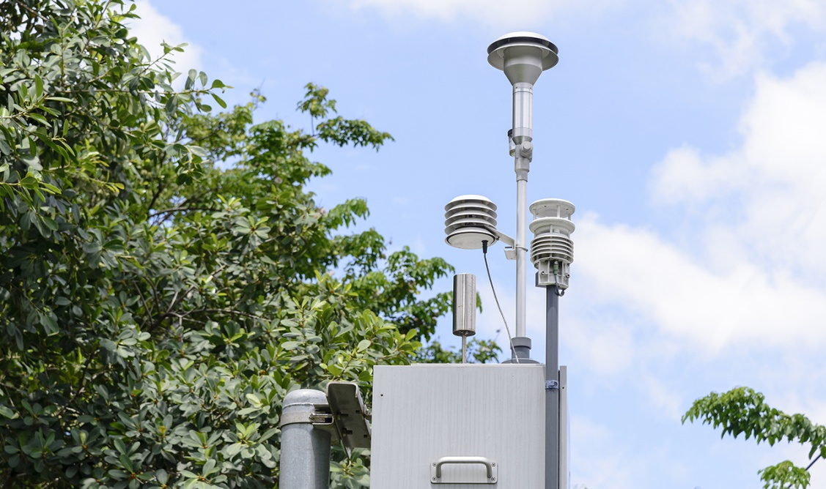

**WATER QUALITY MONITORING**

Water is a vital source for the health of the planet and its people, and today, technology is needed to support clean water management and conservation. Water quality monitoring using IoT-based systems helps to Using IoT systems allows water to be analyzed in buildings, water and wastewater plants, irrigation systems and industrial processes. . IoT technology allows the detection of harmful substances public it reaches homes and buildings. The innovative technology helps us to sustain our health and wellness.  
 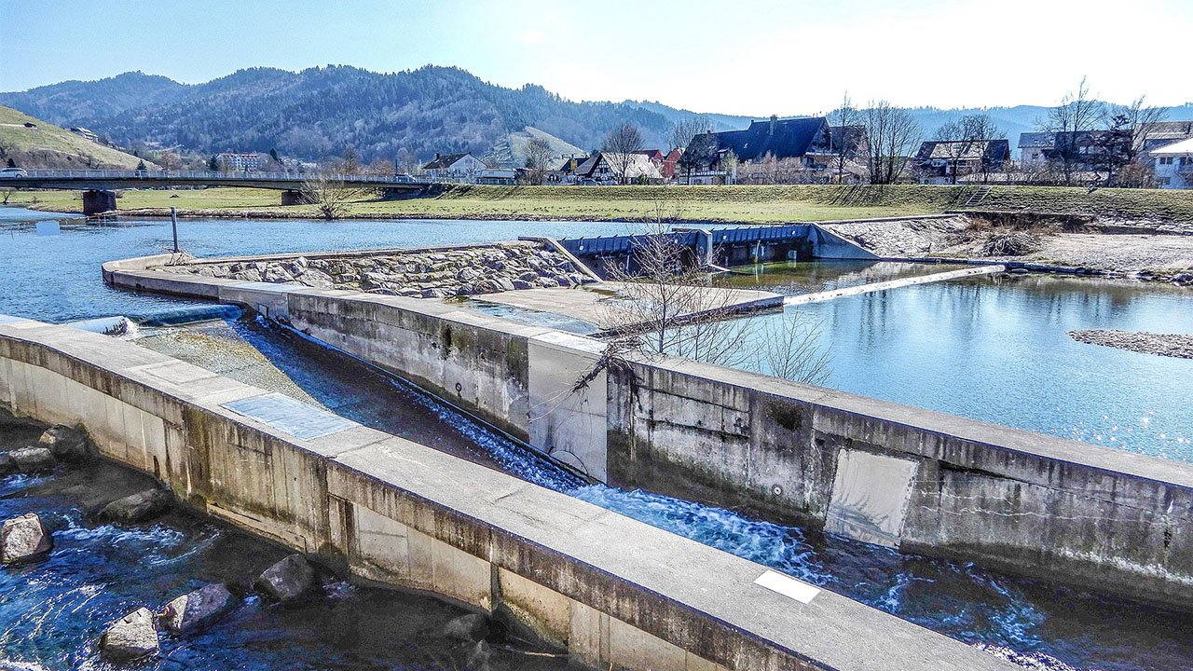

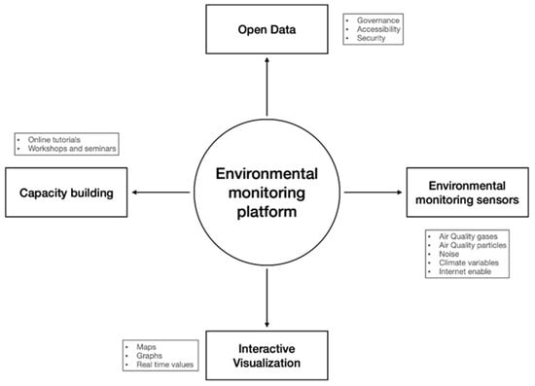

CONCLUSION

There are many challenges when developing and deploying an environmental monitoring platform for air quality and noise level. On one hand, the platform must be flexible to interact with different environmental variables, accessible so that a community can easily use it, and secure to establish trust. Another aspect is how to interact directly with the community to create awareness of pollution and the impact they have in surrounding territories. Different strategies are required to reach the community. In this work, we present a framework for developing such a platform and how it can be used to understand both natural phenomena and human behavior impact on the pollutant and our territories.

THANK YOU